Kindergarten-2nd grade Art Lesson 9/8/20-9/21/20
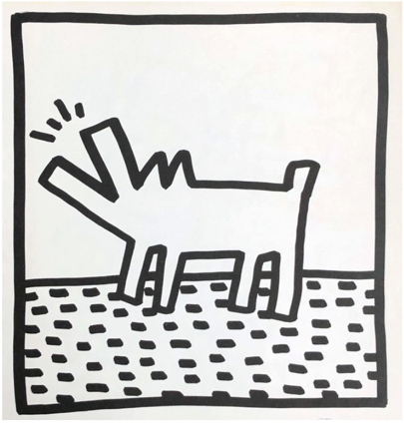
Keith Haring Dog

Kindergarteners, 1st, 2nd graders
can view the Keith Haring Slideshow,
especially the section on DOGS (page 8-12)
https://docs.google.com/presentation/d/1XjCSxX8iouU8bppe6WEOY0Xl41XfTVb63MZ69X2X_zc/edit?usp=sharing

This slideshow is also accessible from the Encinal Art Website
https://encinalart.weebly.com/resources.html

Instructions:
- Draw a Dog with shapes (rectangle, triangle, square) in the style of Keith Haring.
- Cut the dog out with scissors, being careful not to cut the legs or ears off.
- Save this dog for next week. We will add to it by making more dogs, dog toys, dog houses, etc!

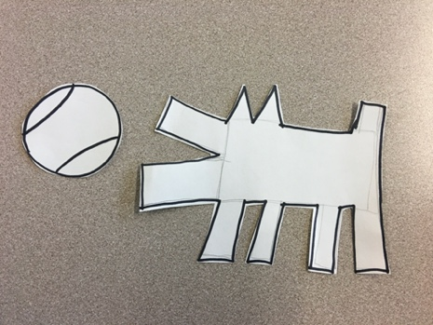
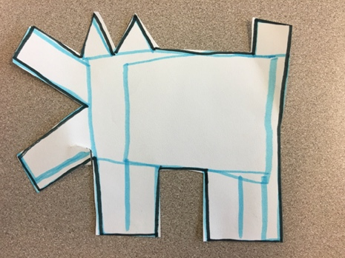
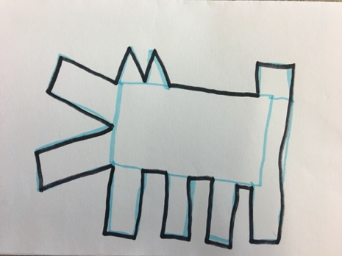

September 8-21, 2020

3rd-5th Art Lesson is on the following page!

3rd-5th Grade Art Lesson 9/8/20 - 9/21/20 ~ Keith Haring Books

3rd-5th graders can view the Keith Haring Slideshow, especially the section on BOOKS (pages 13-18)
https://docs.google.com/presentation/d/1XjCSxX8iouU8bppe6WEOY0Xl41XfTVb63MZ69X2X_zc/edit?usp=sharing

This slideshow is also accessible from the Encinal Art Website (resource page):
https://encinalart.weebly.com/resources.html

Instructions:
3rd-5th graders can create a Flutter or Flip book (instructions on slideshow). Mrs. Noon recommends the Flutter Book as it may be a new method for many and it only requires paper, pencil and scissors. The Flip Book requires a staples or clip to connect the pages. We will continue these next week in Art! Try to fold and cut today and we can add pictures next week.
